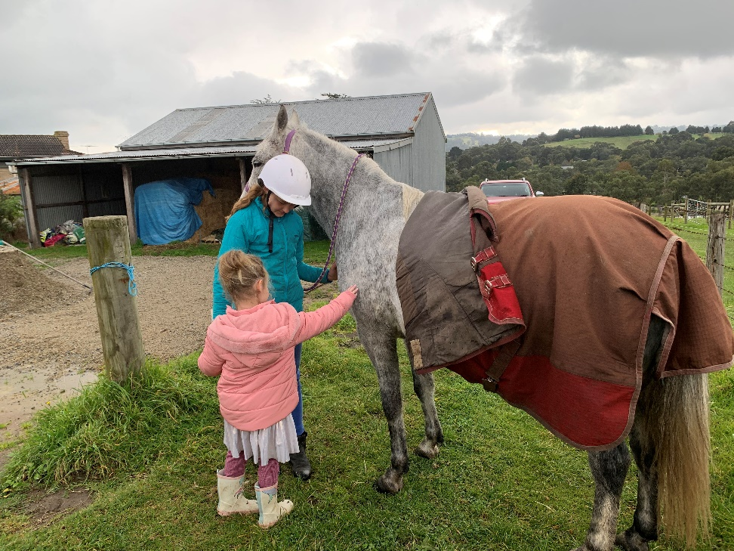
This image is of the first time Ellie met Rosie. I was surprised that Ellie walked right up and patted Rosie.
She didn’t talk until we went for a walk with Rosie.

This image is of me showing Ellie all the horses and ponies on our agistment.
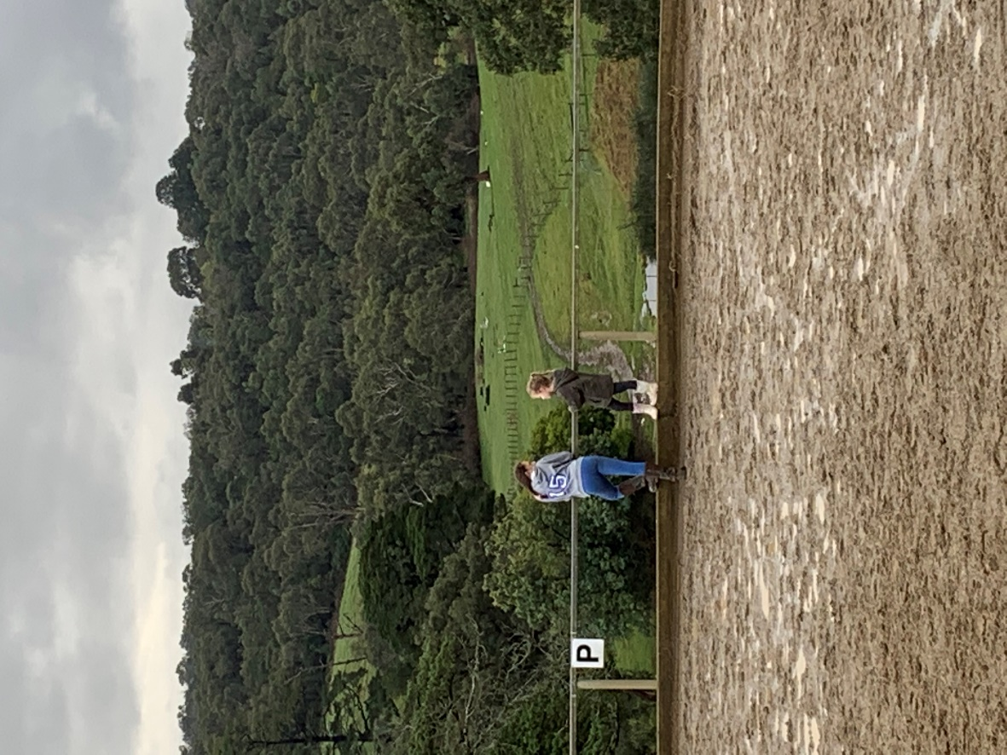
After this photo was taken Ellie and I did trotting with Rosie.

